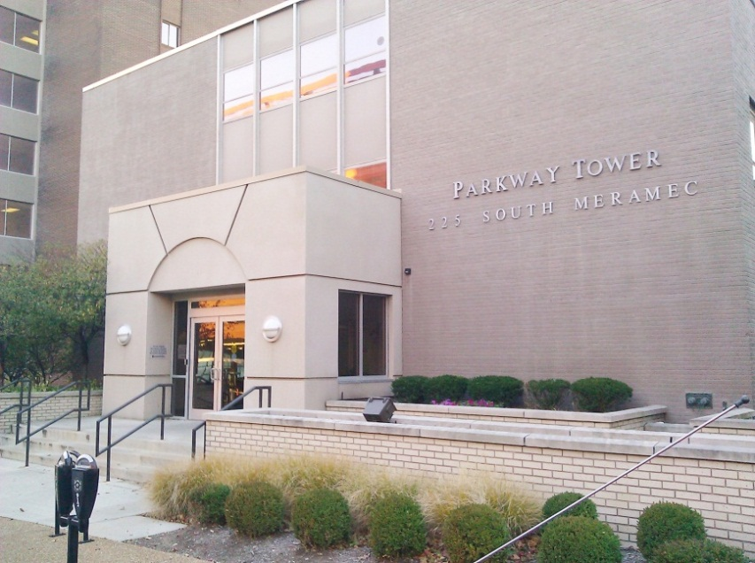 | Multicultural Counseling and Research Center  225 South Meramec Ave, Suite 203  Clayton, MO 63105  Office: 314-445-5678  Fax: 314-261-5029  Our office is located in a building called Parkway Towers (picture on left). Once you enter the building (on the 3rd FL), take the elevator on your right to the 2nd FL. Our office will be on the left side as you exit the elevators. Please open our office door and you can have a seat in the waiting area until we greet you.
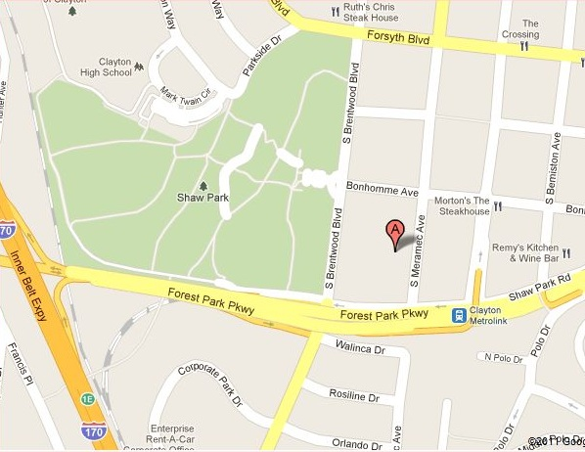 | Our office is readily accessible by HW40 & HW170. We are located directly across from the Clayton MetroLink station as well as the Metrobus Transfer Center, a big hub for connecting bus routes. We are approximately 3 traffic lights up from the Galleria Mall on Brentwood Ave.  You will need to find an available parking meter (from 8-5pm Mon-Fri) or you can use the parking garage across the street (75 cents/hr). After 5pm, meter parking is FREE, you also do not need to pay the parking meters on Sat. or Sun.
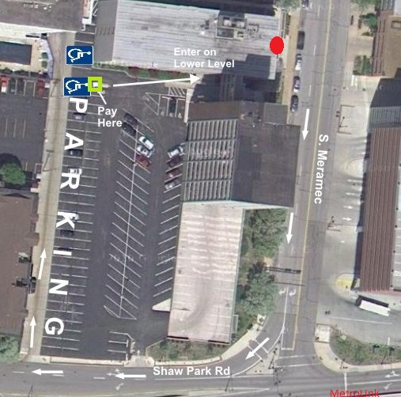 | You can also park for FREE behind the building. Below is picture of the free parking area (labeled PARKING in picture). It is the row "outside" of the open area parking. After you make a right turn on Shaw Park Rd, you will turn into an “alley” to get to the last row. When you park, you can walk to the "booth" labeled "Pay Here" and get a yellow ticket from the attendant (if someone is there). If no one is at the booth you can walk directly to lower level entrance and take elevators to 2nd floor. In the picture the red dot is the front entrance of the Parkway Tower building.  If you arrive on the weekend the lower level entrance may be locked. To unlock the door, PRESS “1821” on the “keypad” to the right of the door and the door will automatically unlock for you to enter the building.

